Black Bean and Quinoa Stuffed Pepper
Ingredients
3 red bell peppers, washed, seeds removed and cut in half
1 T. olive oil
½ c. onion chopped fine
1- 15 oz can of black beans rinsed
1c. of quinoa
2 c. of water
½ c. scallions
2 clove garlic
2 oz canned green chiles
1 T cumin
Salt and pepper to taste.
½ c cheese
Preheat oven to 400 degrees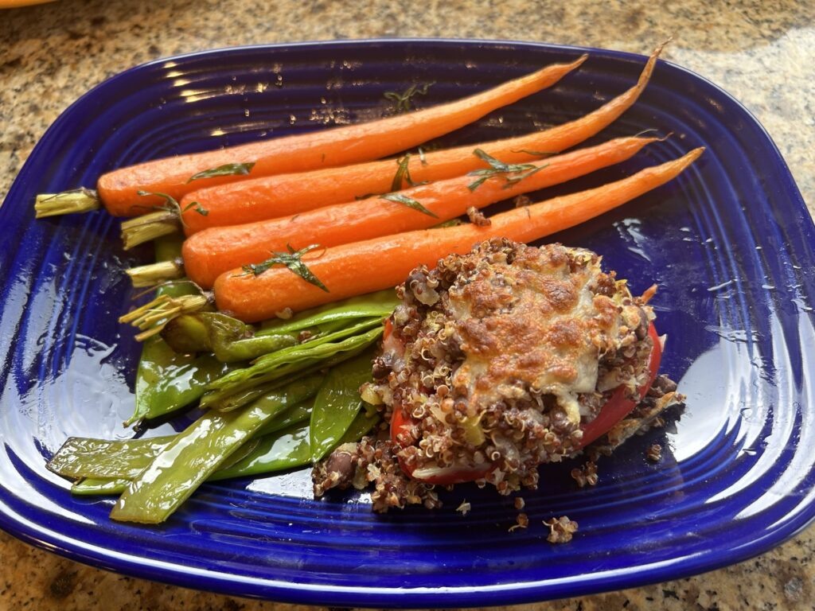
Directions:
- Cook 1 cup of quinoa in 2 cups of water until tender.
- Wipe down peppers with olive oil, place on a baking sheet, and place in oven for 10 minutes.
- In a large sauté pan; sauté onions and scallions for 3-5 minutes, add garlic and sauté for another minute.
- In a large bowl, mix together quinoa, black beans, chiles, sauteed vegetables, and cumin.
- Add 1 T of olive oil to a baking dish and arrange peppers evenly on the dish. Evenly divide quinoa mixture among peppers.
- Top with 1T. shredded cheese and bake in a 350 degree oven for 25-30 minutes until heated through and bubbly.
Remove from oven, garnish with remaining green onions.
Nutrition (makes 6 servings) Calories 221, fat 6 g; carbohydrates 32g; fiber 7.6g; protein 12 g.

